**Derivation of Supply Curve of PV.**

Seungho Jeona, Gildong Hongb, Gyeonggi Dob,[1]*

a *Climate & Environment Data Center, Gyeonggi Research Institute, South Korea*

b *Climate & Environment Data Center, Gyeonggi Research Institute, South Korea*

**Abstract**

This is an abstract.

**Keywords:** Keword1, Keword-2, Keyword-3

1. Introduction

This is an introduction.

1. Gyeonggi province in South Korea

This is the second chapter.

ssssssssssssssssssssssssssssssssssssssssssssssssssssssssssssssssssssssssssssssssssssssssssssssssssssssssssssssssssssssssssssssssssssssssssssssssssss

ssssssssssssssssss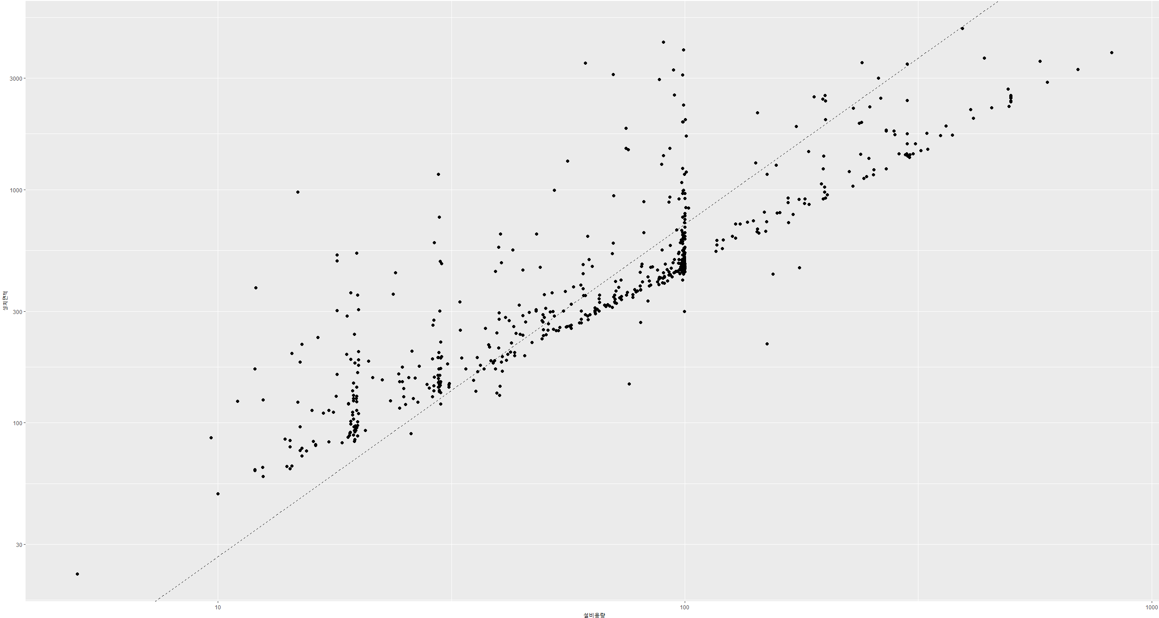

1. Methodology
   1. Data & GIS program

GCAM

* 1. Data

Population

* 1. Scenario
  2. Gini coefficient

Gini

$$G_{t,s}=1- \sum_{r=1}^{229}{{(X}_{r,t,s}-X_{r-1,t,s}){(Y}_{r,t,s}+ Y_{r-1, t,s})}$$

1. Results
   1. Electricity sector

Sdfsd Elecit

Geographical

ssssssssssssssssssssssssssssssssssssssssssssssssssssssssssssssssssssssssssssssssssssssssssssssssssssssssssssssssssssssssssssssssssssssssssssssss

* 1. Implications for T&D networks

The last ssssssssssssssssssssssssssssssssssssssssssssssssssssssssssssssssssss

sssssssssssssssssssssssssssssssssssssssssssssssssssssssssssssssssssssssssssssssssssssssssssssssssssssssssssssssssssssssssssssssssssssssss

1. Conclusion

Electrification ssssssssssssssssssssssssssssssssssssssssssssssssssssssssssssssssssssssssssssssssssssssss

**CRediT authorship contribution statement**

**Seungho Jeon:** ABC. **Gildong Hong:** ABC. **Gyeonggi Do:** ABC

**Declaration of competing interest**

The authors declare that they have no know competing financial interests or personal relationships that could have appeared to influence the work reported in this paper.

**Acknowledgement**

This work was supported by Korea Ministry of Environment (MOE) as Graduate School specialized in Climate Change.

References

1. * Corresponding author.

   *E-mail addresses:* [shjeon@gri.re.kr](mailto:shjeon@gri.re.kr) (S. Jeon), [rohmin9122@gmail.com](mailto:rohmin9122@gmail.com) (M. Roh), [k123mt@ajou.ac.kr](mailto:k123mt@ajou.ac.kr) (M. Kim), [jaeickoh@gmail.com](mailto:jaeickoh@gmail.com) (J. Oh), [suduk@ajou.ac.kr](mailto:suduk@ajou.ac.kr) (S. Kim)